Assessment on Mass Flowering of Ethiopian Highland Bamboo at Jiggo and its Surroundings
The Jiggo highland bamboo bamboo forest is located in the Southern Nations and Nationalities and Peoples Region (SNNPR), Gedeo Zone, Bule district. It covers more than 350 ha of land, the widest bamboo forest in the woreda, with desirable stand structure and with high socio-economic and ecological significance for the nearby communities. To our surprise, it is recognized that the forest had escaped from bamboo cover assessments made in earlier bamboo inventories by LUSO CONSULT (1997) and Ensermu et al. (2000) and so on. Its existence was known at national level later during 2007-2011.
With the objective of identifying the root causes of mass death of the Jiggo bamboo forest, the director of Hawassa Environment and Forest Research Center (HEFRC) together with multidisciplinary team who have specialty on bamboo, forest pathology and forest entomology from the Ethiopian Environment and Forest Research Institute (EEFRI) (head quarter) and the head of SNNPR Environmental Protection and Forest Authority (EPFA) and senior experts of the region visited the Jiggo bamboo forest on 26 September 2016. The team assessed Jiggo and its surrounding and discussed the issue with the nearby community.
Based on the visual observation by making transect walk within the area and quick discussion made (Figures 1, and 2), it was learnt that the mass death of Jiggo bamboo forest is caused by mass flowering. Most bamboos, including the Ethiopian species, flower only once in their life time and die then after to set seeds.
Back from Jiggo, discussion was made with staff of Gedeo zone at the zonal capital, Dilla. The discussion was made with the Administrator of Gedeo Zone and head of Gedeo Zone Environmental Protection and Forest Authority office. Following the discussion, responsibilities were given to each party: EEFRI to technically support the restoration of the site with the wildlings that are growing underneath the heavy broad leaved weeds by applying different management techniques and by introducing other bamboo clones and bamboo species in the area. SNNPR- EPFA to coordinate all the activities in restoring the area and to make inputs available, Gedeo Zone administration to coordinate the activities of the woredas and to protect the area from any intervention by animals and human beings that might change of the area to any other purpose.

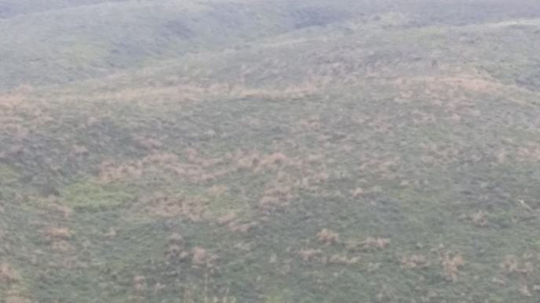
Figure 1. The landscape of Jigo bamboo forest, after mass flowering and mass death

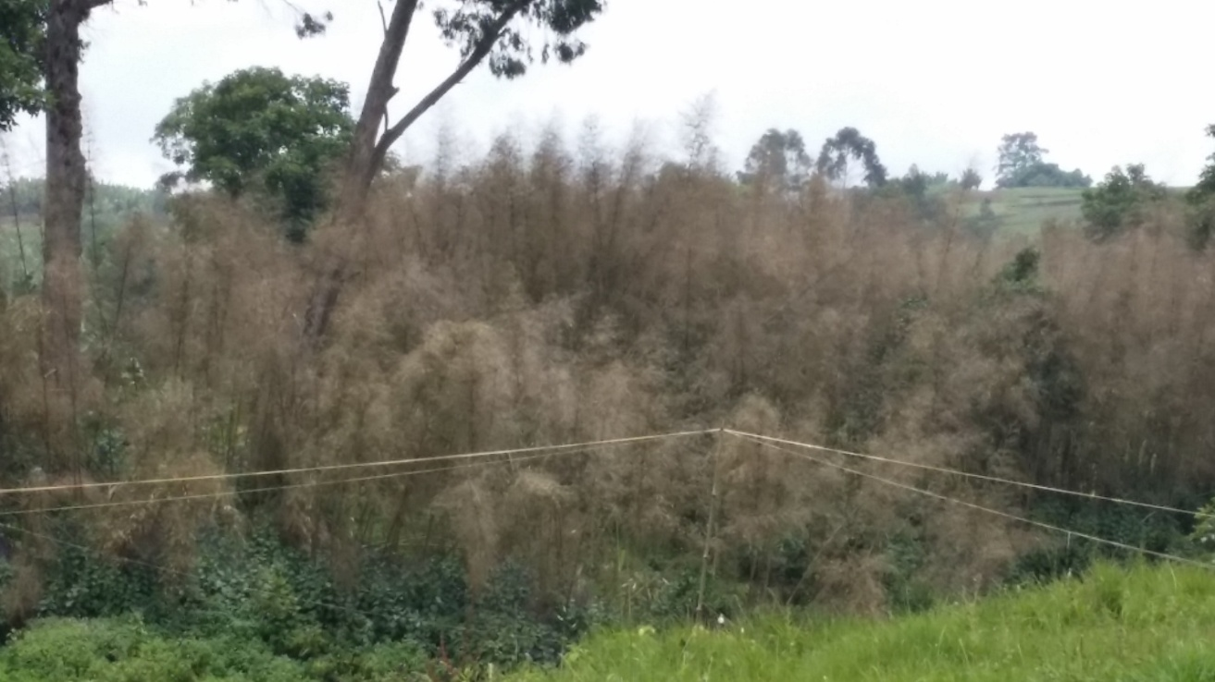
Figure 2. Dried bamboo forest after mass flowering; Photo taken 16 Sept. 2016
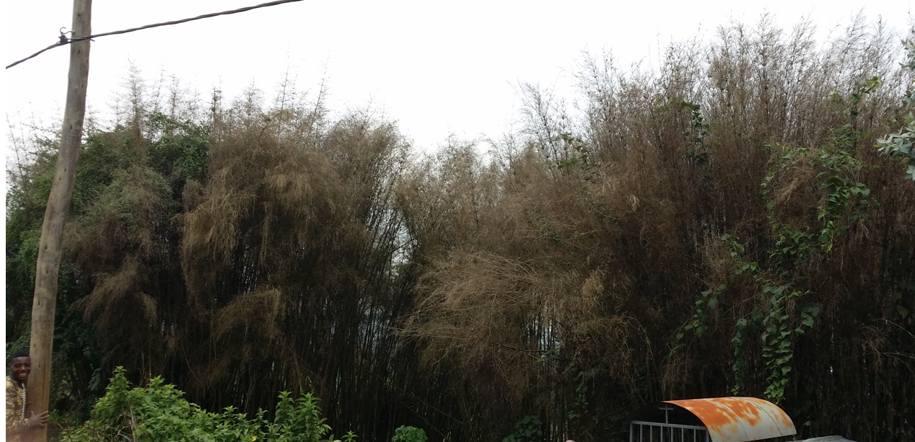 Figure Figure 3. Dried bamboo stand after mass flowering; Photo taken 16 Sept. 2016
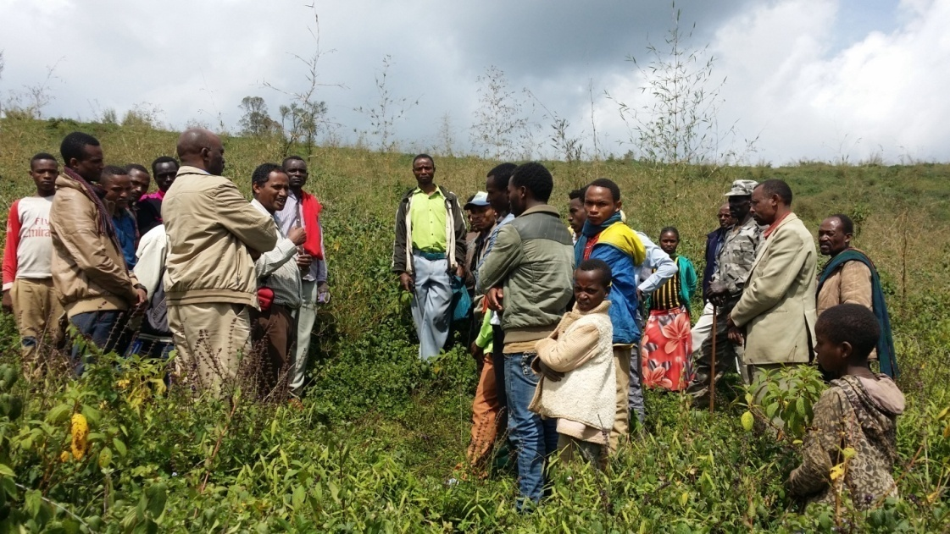
Figure 4. Discussion on what to do to restore bamboo after mass death

